**Third monitoring programme for the Capp Plast NTN “LDPE materials and articles in which the recycled plastic is used behind a Functional Barrier”**

In accordance with the requirements of Article 13 of Regulation (EU) 2022/1616, we are herewith reporting the results of the third monitoring programme relative to the placing into the market of LDPE- base ABA structures, where the B layer consists of Recycled LDPE (rLDPE).

This report should be read in conjunction with the dossier referred as Capp Plast NTN “LDPE materials and articles in which the recycled plastic is used behind a Functional Barrier”, submitted on 10th July 2023.

The present report is built out of the analysis that have been carried out by external qualified laboratory (compliant to Standard EN 17025); these data have been obtained with different analytical approaches, nevertheless they provide a clear vision of the substances referred to in Article 13(5)(c) of the Regulation.

1. Description of the Functional Barrier technology

rLDPE is used in food contact materials for indirect contact application with food, the rLDPE is mildly decontaminated by mechanical process, and subsequently embossed between two layers of virgin LDPE, so the layer in contact with food acts as “functional barrier”, preventing potential contaminants in the rLDPE to be transferred to food in a quantity that endangers human health and, therefore, making the final structure compliant with Regulation (EC )1935/2044, in particular with art 3 thereof.

The dossier deals exclusively with the PE packaging materials which include the functional barrier, where the rPE is not in direct contact with food.

Starting from a dried flakes of LDPE derived from post industrial collection, the manufacturing of A/B/A structures include the following processes:

• Grinding phase of the post industrial plastic waste (collection of Food grade film compliant to Regulation 10/2011) to produce flakes

• An extrusion phase, where flakes are melted to produce the rLDPE granules to be used into B layer with application of vacuum. The temperature profile is usually 270-290°C. When vacuum is applied, the vacuum conditions are typically below 100 mbar.

• The coextrusion step, in which the A layers are applied at a temperature of typically 275-290°C. A 3-layer sheet (A/B/A) comes out from the coextrusion process and it is cooled down.

1. Capability of decontamination of the Functional Barrier technology

The decontamination efficiency was referred to model contaminating substances, referred as “surrogate contaminants”, that are normally used for testing the decontamination capabilities of PET recycling processes. Based on that data, modelling of migration of surrogate contaminants has been carried out starting from concentration of these contaminants of 3 mg/kg (EFSA assumption).

The Challenge Test is still running during this month

We have analyzed the maximum amount of rLDPE in the B layer of different ABA structures at which the concentration of the surrogate migrating at the highest rate of lies below the level of 0.15 microgram/kg food recommended by EFSA as safety level, by assuming that all migrating contaminants are genotoxic.

The calculation was carried out in t use conditions of 10 days at 40°C

1. List of contaminating substances with molecular weight < 1000 Dalton

The list of substances found in the plastic input (flakes) is reported in Table 1.

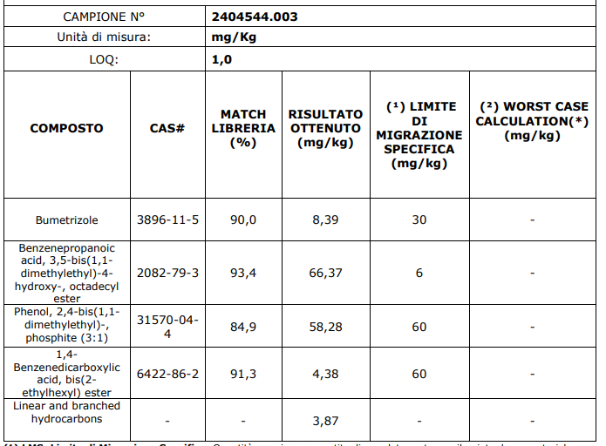

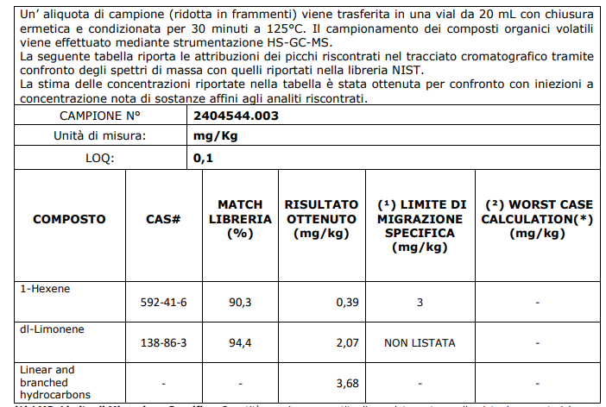

Table 1: substances found in plastic input (flakes DLPE – post industrial Capp Plast collection)

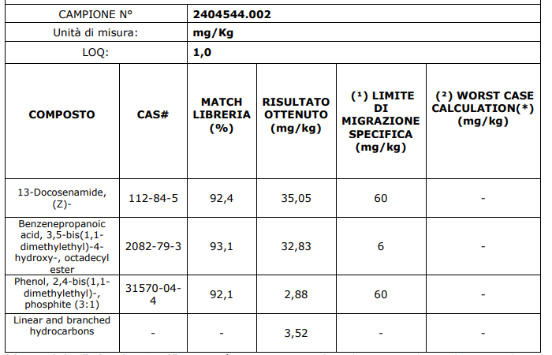

Table 2: substances found after I level decontamination (granules LDPE – post industrial Capp Plast collection)

The list of the substance found in the plastic output (film) is reported in Table 3.

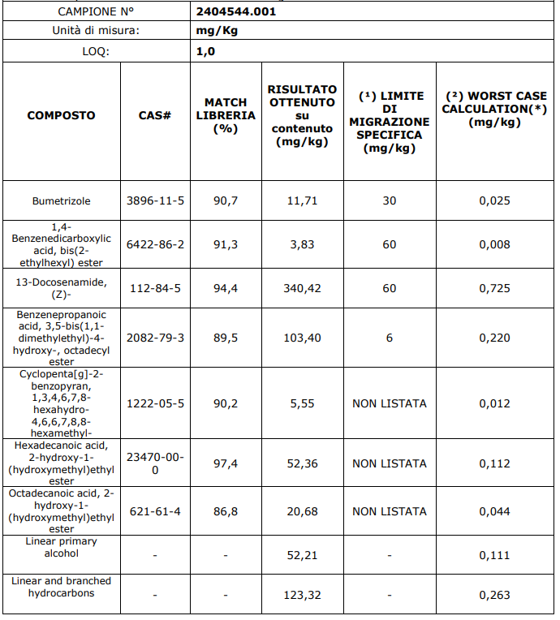

Table 3: substances found in plastic output (film)

1. List of contaminating materials in plastic input

The content of food grade rLDPE in the plastic input is ≥95%. Other contaminants include:

* PVC ≤ 50 ppm
* Polyolefins ≤ 100 ppm
* Other plastics ≤ 50 ppm
* Metals ≤ 10 ppm
* Paper and wood fibres ≤ 10 ppm
* Other inert materials ≤ 5%

1. Most likely origin of contaminants

The sources to which the presence of substances in the input and output plastic can be attributed are listed below:

* Components of LDPE (POSH)
* Chemicals originate from environmental contamination (e.g. benzene, BPA) by external recyclers
* Substances, especially plasticizers, derived from glues used in labels (phthalates, benzophenone and others) residuated in recycled LDPE bought by external supplier
* Antioxidants, mostly present in polyolefins (e.g. BHT, Ingafos 168 and its decomposition products)
* Other substances of unknown origin

1. Description of the analytical procedures

Various analytical methods have been used to detect the substances in input and output plastics. The analytical equipment is usually composed by

* Headspace GC for analysis of volatile substances, with or without SPME
* GC- Mass Spectroscopy for semi volatile substances, usually with MS/FID detector, and with or without QTOF
* Liquid Chromatography with Mass Spectroscopy, with or without QTOF detector, for semi volatile and volatile substances.